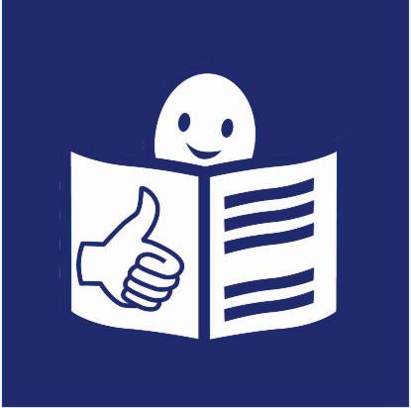
The Human Rights Council
of the United Nations

What is the United Nations?

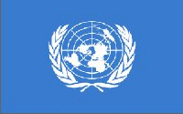
The United Nations is a group of countries.
Almost all countries in the world
are part of the United Nations.

The United Nations works to
make the world a better place for all.

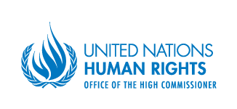
What is the Human Rights Council?

The Human Rights Council is
a part of the United Nations.

It works to make sure that:

- All people know about their rights.
- All people can use their rights.

Rights are things that should happen for everyone.
For example, everyone has the right to:

- to live
- be treated fairly
- go to school
- have a say in the way his or her country is run

What does the Human Rights Council do?
The Human Rights Council does different things:

- It makes sure that all people
understand their rights.

- It makes sure that all people
have the same rights.

- It checks if all people
can use their rights.

- It checks what governments do
to protect the rights of people
in their countries.

- It checks if governments do
what they agreed on
at the United Nations.

- It helps people whose rights were taken away.

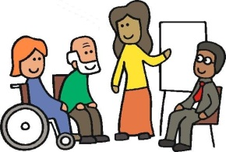
To do all the work, the Human Rights Council gets help
from groups of experts.
They are called ‘Advisory Committees’.

Sometimes, the Human Rights Council also works with
other experts who know a lot about 1 right or 1 country.
When this happens, we call it ‘Special Procedures’.

How does the Human Rights Council work?

The Human Rights Council started working in 2006.
It decided rules for its work.

All countries at the United Nations
take part in the work of the Human Rights Council.

But only some countries make decisions.
There are 47 countries making decisions
in the Human Rights Council.

All countries at the United Nations take part in choosing
these 47 countries.

